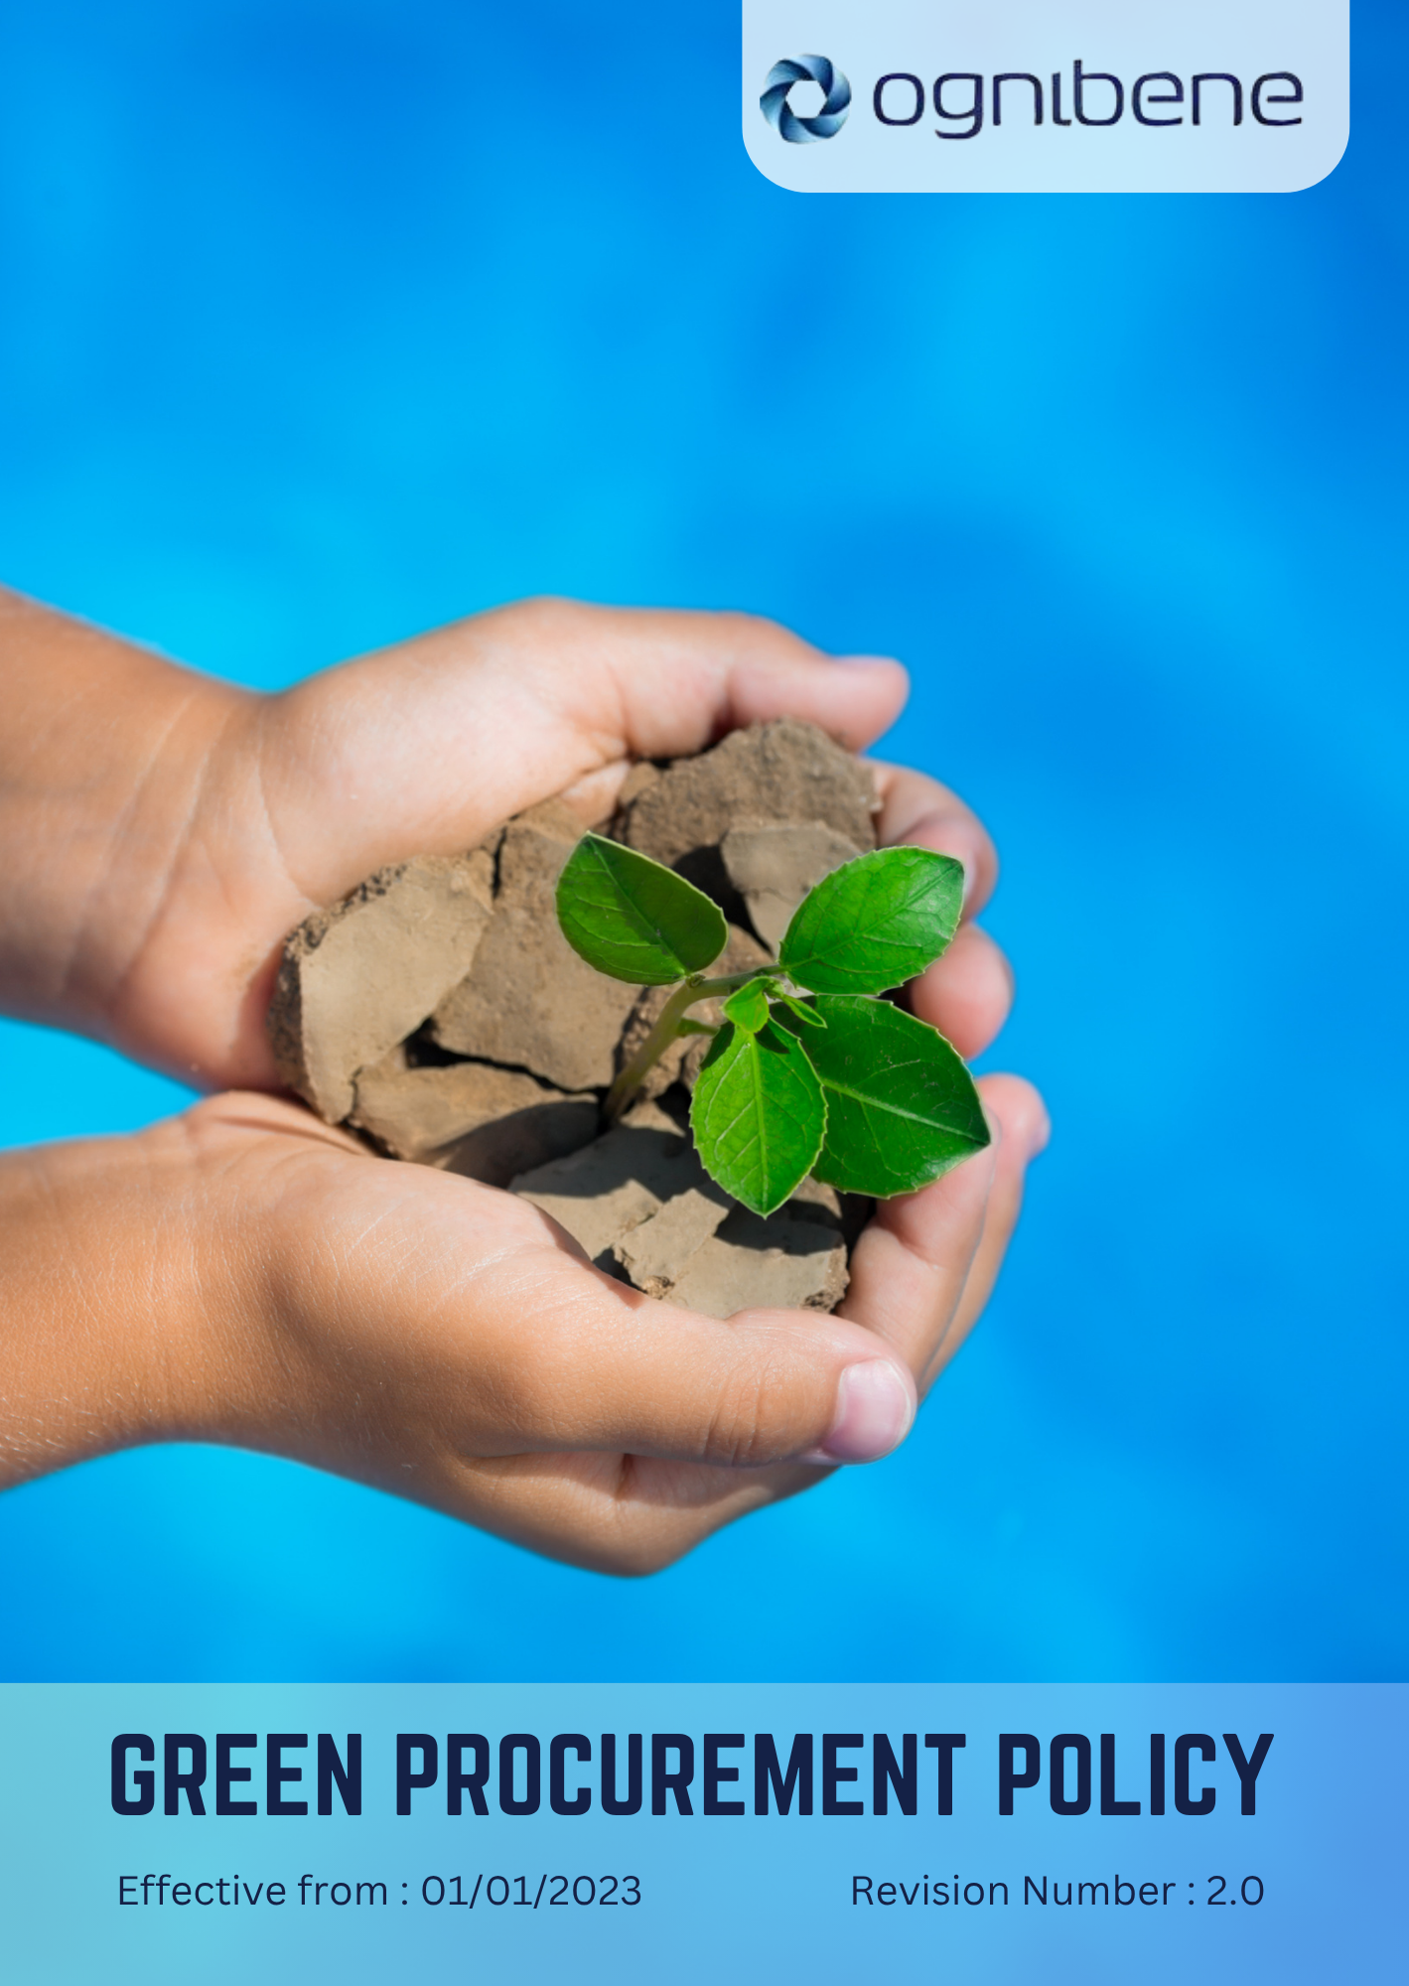

TABLE OF CONTENTS

Introduction 3
Scope 3
Policy Statement 3
Key Focus Areas 3
General Targets 5
SDGs Covered 5
Responsibility 5
Review Mechanism 6
Revision History 6
Acknowledgement 7

Introduction
OGNIBENE INDIA PVT LTD, incorporated on February 10, 2006, is dedicated to designing and manufacturing hydraulic cylinders and hydraulic steering systems for off-highway vehicles, automotive, and marine applications. We are committed to ensuring that our procurement practices contribute to sustainable development. This policy outlines our commitment to integrating environmental and social considerations into our procurement decisions.

Scope
This policy applies to all workers, employees, directors, officers, agents, contractors, and any third parties acting on behalf of OGNIBENE INDIA PVT LTD (OIL). It covers all business activities, including procurement, sales, marketing, and any interactions with government officials, customers, suppliers, and other stakeholders. The policy is applicable globally, regardless of local business practices or cultural norms. This policy applies to below mentioned locations:
Unit 1: | Ognibene India Private Limited – Pune Plant (I)  Plot A-13 Talegaon MIDC Village Ambi Navlakh Umbhre Talegaon, Pune Maharashtra – India
Unit 2: | Ognibene India Pvt. Ltd.  Unit No.A, B-600, Plot No.8, Ishanvi Industrial & Logistics 140402 Park, Vividha Ind.Park, Chamaru, Rajpura Patiala – Punjab – India

Policy Statement
Ognibene India Pvt. Ltd. is committed to sustainable procurement by ensuring suppliers uphold strong environmental and social standards. We aim to reduce environmental impact and ensure fair labor practices while balancing sustainability with price, quality, and reliability in our supply chain.

Key Focus Areas
Below are our commitments and targets towards environmental sustainability as compared to baseline year 2023.
- Supplier Environmental Practices
Commitment: Ognibene India Pvt. Ltd. aims to work with suppliers to reduce waste, improve energy efficiency, and lower carbon emissions. By 2030, we will ensure that 25% of our suppliers have implemented waste reduction initiatives, and at least 20% will have adopted energy efficiency measures, achieving a 10% reduction in carbon emissions compared to the 2023 baseline. 40% of key suppliers transition to renewable energy usage by 2030.
- Supplier Social Practices
Commitment: We are committed to ensuring that all suppliers adhere to fair labor standards, including providing fair wages, safe working conditions, and reasonable working hours. By 2030, 100% of suppliers in high-risk regions comply with international labor standards, and 100% of total suppliers meet fair wage and working hour requirements. 100% of direct employees and 100% of indirect supplier employees receive training on human rights and ethical conduct by 2030.
- Resource Efficiency
Commitment: Ognibene will collaborate with suppliers to enhance resource efficiency, particularly in the use of energy, water, and materials. By 2030, 30% of our key suppliers will reduce their water and material consumption by 15% from the 2023 baseline, and 20% of suppliers adopt resource monitoring systems, and a 30% reduction in non-recyclable materials used in supplier packaging is achieved by 2030.
- Waste and Circularity
Commitment: We aim to promote waste reduction and circular economy principles in our supply chain, focusing on recycling, reuse, and reducing packaging waste. By 2030, 70% of suppliers implement recycling programs and achieve a 20% reduction in packaging waste compared to the 2023 baseline. 50% of suppliers integrate product life cycle or take-back initiatives by 2030.
- Supplier Compliance and Transparency
Commitment: Ognibene India Pvt. Ltd. is committed to ensuring supplier compliance with environmental and social regulations, promoting transparency in their operations. By 2030, 90% of our suppliers will provide annual environmental, social and governance performance reports, and 100% will undergo third-party sustainability audits.
- Supplier Capacity Building
Commitment: To support suppliers in adopting sustainable practices, Ognibene will provide training, guidance, and resources. By 2030, 100% of our strategic suppliers will receive sustainability training, and 50% will report measurable improvements in their sustainability performance. Biannual supplier workshops on sustainable sourcing continue through 2030.

- Community Engagement
Commitment: We commit to engaging with local communities impacted by our supply chain operations. By 2030, 100% of production sites have community engagement initiatives in place, and community satisfaction scores increase by 15% compared to the 2023 baseline. Supplier participation in local CSR and environmental programs increases by 10% annually through 2030.

General Targets
To strengthen our sustainable procurement framework and ensure a responsible supply chain, Ognibene India Pvt Ltd has set the following overarching targets applicable to all suppliers and business partners:
- 100% of our suppliers are required to sign and comply with our Supplier Code of Conduct to ensure alignment with our ESG principles and ethical standards.
- 100% of our suppliers will actively participate in ESG training programs annually, fostering a culture of continuous improvement and awareness.
- We will conduct on-site supplier audits and worker feedback assessments for 100% of our critical and high-risk suppliers to ensure compliance with environmental, social, and governance standards.
- 100% of our suppliers will be required to complete an annual ESG self-assessment, allowing us to monitor progress, identify gaps, and collaborate on improvement plans.

SDGs Covered
OIL is committed to achieve the following Sustainable Development Goals:





Responsibility
The Chief Procurement Officer (CPO) is responsible for overseeing the implementation of this policy, ensuring that procurement activities align with sustainability objectives. The Supply Chain Manager will conduct supplier assessments and audits to ensure compliance with the outlined environmental and social standards. Additionally, the Sustainability Manager will collaborate with suppliers to promote sustainable practices, provide necessary guidance, and track progress toward achieving the quantitative targets outlined in the policy. All team members involved in procurement are responsible for integrating these standards into daily operations and supplier interactions.

Review Mechanism
This policy will be reviewed bi-annually by the Chief Procurement Officer (CPO) and Sustainability Manager to ensure it remains current with evolving sustainability goals and industry best practices. Necessary updates will be communicated to all stakeholders, and any required changes will be implemented promptly.

Revision History
Revision No. | Date | Description of Changes | Approved By
0.0 | 01 Jan 2023 | Initial Policy Draft | General Manager Operations
1.0 | 01 Jan 2024 | Updated Scope and add the Acknowledgement section | General Manager Operations
2.0 | 01 Jan 2025 | Updated Key Focus Areas revised with action-oriented commitments and introduced the General targets and Revision History table | General Manager Operations

Approved by: General Manager of Operations
Last Review Date: 01 JAN 2025 Next Review Date: 01 JAN 2027

Acknowledgement
I, ________________________, acknowledge that I have read, understood and agree to adhere to the company’s Green procurement Policy. I recognize the importance of my role in supporting the company's commitment to sustainable procurement policy and am committed to actively participating in the implementation of this policy. I will strive to incorporate sustainable procurement responsible practices into my daily work activities, comply with all relevant sustainable regulations and company policies and support the continuous improvement of our environmental performance.

I understand that my commitment is essential in achieving the company's sustainable objectives and fostering a culture of sustainability. I am dedicated to contributing to our shared vision of a sustainable future and demonstrating our dedication to sustainable stewardship.

Employee Name:
Employee Signature:

